TASK 1

1.1 Bootstrap kubernetes cluster on your laptop using kubeadm.

Step : 1 Swap off by : - swapoff -a command in root account.

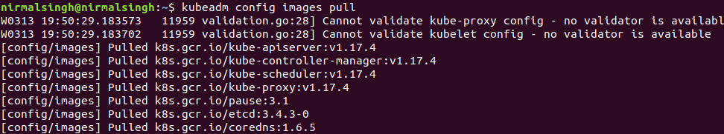
Step : 2 Pull required images for master nodes.

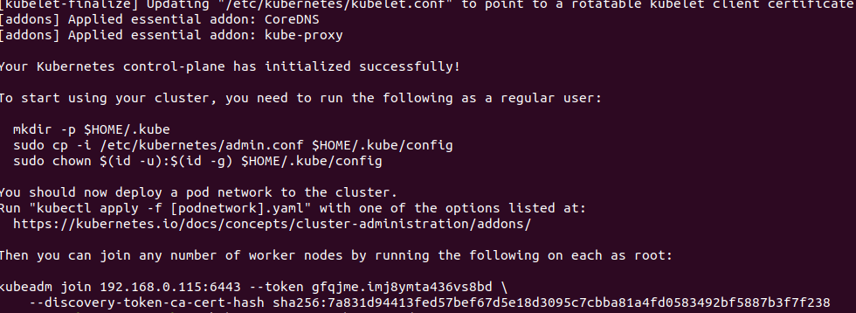
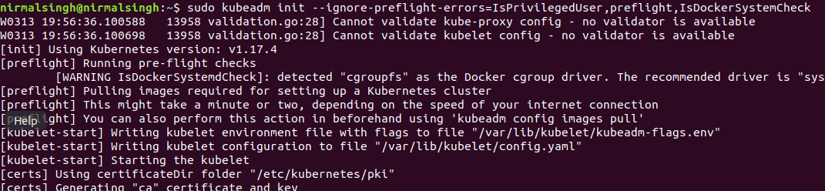
Step : 3 Now run kubeadm init command.

Step :4 now copy the the below given commands in order to access the kubectl utility.

